ARDFINNAN COMMUNITY PLAYSCHOOL
PARENTS HANDBOOK

Address: LADY’S ABBEY, ARDFINNAN, CLONMEL, CO. TIPPERARY
Eircode: E91RP21
Telephone: 052/7464488 & 086/1762095
Email: ardfinnanplayschool@gmail.com
Website: www.ardfinnanplayschool.com
Ardfinnan Community Playschool is operated by Ardfinnan Childcare Committee Company Ltd.by Guarantee (ACCCL)
CONTENTS
WELCOME |  | 3
MISSION STATEMENT |  | 3
GDPR DATA PROTECTION |  | 3
ALL ABOUT US |  | 4
OUR STAFF |  | 5
AWARDS |  | 5
PARTNERSHIP WITH PARENTS & GUARDIANS |  | 6
PROCEDURES FOR PARENTS STARTING THEIR CHILD | 7
CELEBRATIONS |  | 8
ALLERGIES |  | 8
INCLUSION |  | 8
LINC & AIM |  | 8
CHILD ARRIVAL & COLLECTION |  | 9
SETTLING IN |  | 10
CONFIDENTIALITY |  | 12
FEES |  | 12
RECORD KEEPING |  | 12
SOCIAL MEDIA |  | 13
OUR PLAY BASED CURRICULUM |  | 13
OBSERVATIONS |  | 16
DAILY ROUTINE |  | 17
HELATHY EATING |  | 17
HAND HYGIENE |  | 19
AISTEAR |  | 20
SÍOLTA |  | 20
CLEANING |  | 22
STEPS TO ELIMINATE THE RISK OF INFECTION |  | 23
TERMS & CONDITIONS |  | 24
Welcome to Ardfinnan Community Playschool
Throughout this handbook we would like the opportunity to tell you in a bit more detail what we are about. Please allow yourself some time in reading this handbook, it will help you understand how Ardfinnan Community Playschool is run and provides lots of practical points.
We recognise that as parents you are the first educators in your child’s life, and we are here to support you in that role. Through play children learn many life skills such as how to interact with others and different ways of thinking, at Ardfinnan Community Playschool we encourage children to explore the world around them through the medium of play.
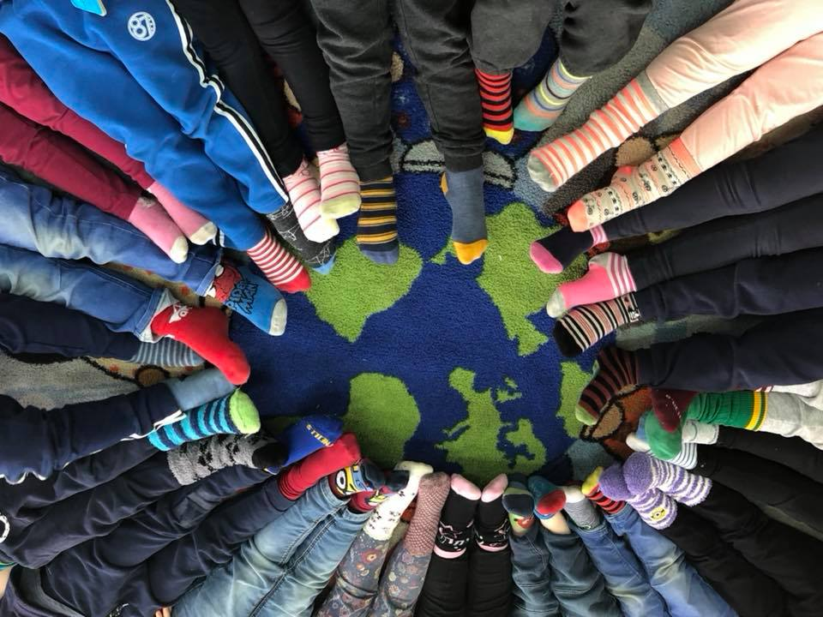
Mission statement
Ardfinnan Community Playschool is operated by Ardfinnan Childcare Committee Company Limited by Guarantee. The object for which the company is established are:
Provision of high quality, affordable and accessible community-based childcare facility, enabling parent’s avail of education training and employment opportunities and all related activities.

Ardfinnan Community Playschool aims to provide a:
Quality open, welcoming child centred service, where children will grow and learn in a safe environment. Begin to explore, discover, and adjust socially through play situations, under the guidance of suitably qualified adults and interested parents and guardians, in a service where health, safety, welfare needs and rights of all children in our care is one of the utmost importance

General Data Protection Regulation, GDPR 2016

Ardfinnan Community Playschool is fully compliant with GDPR and has an extensive data protection policy which is available to view at any time. We follow guidelines set down by the “Data Protection Acts2 of 1998 & 2003 and the 2016 General Data Protection Regulation (GDPR) to ensure all personal information gathered is held in a secure manor and can only be accessed by authorised personnel. Personal information will not be shared with any third parties and is only used to provide tailored care and education to your child.
All About Us
Ardfinnan Community Playschool was established in 2004 with the aim to provide a safe stimulating and friendly environment in which your child can grow and express themselves. A place where each child is cared for, listened to and their interests are catered for.

Ardfinnan Community Playschool is registered with Early Childhood Ireland. It is a committee run, non- profit-making group. We are a sessional service operating over a 38-week year offering morning and afternoon sessions.
Morning Sessions | 9:00 to 12:00 | Monday to Friday
Afternoon Sessions | 1:00 to 4:00 | Monday to Thursday

Our playschool caters for 22 children per session. Staff ration is 11 children to 1 adult therefore there will be 2/3 staff present at all times.
Our playschool day consists of:
- Enjoying learning activities through play
- Playing actively both indoors and outdoors
- Solving problems through play and communication
- Learning how to get along with other children and make friends through play
- Listening to stories
- Eating our healthy snack
- Learning about the environment we live in
These activities are supported by playing with water, sand, paint, colours, blocks, jigsaws and much more. We learn how to look after ourselves by putting on our coats, opening our lunch boxes and washing our hands.
We learn the safe cross code and all about the community we live in; we participate in a series of walks visiting our local area.
We have story time and in our circle we all hear each other’s news.
We watch the seasons change our environment, learn why nature is a big part of our lives, sing songs to help us learn the days and months.
We learn to recognise our names and shapes, which aids our literacy skills and practice our pre-writing skills by drawing, writing our names and colouring. We learn science and maths skills pouring and filling water and sand, counting our friends, taking turns playing games like “what time is it Mr Wolf”
While playing we learn how to problem solve, negotiate with others to find a solution, and encourage interactions and friendships all benefiting our language development.

By providing space and opportunities to PLAY we support and enhance each child’s emotional, social, cognitive, physical, and academic development

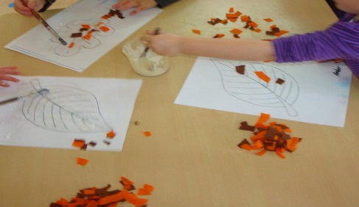
Our Staff
Our Early Years Educators
Erica Condon is our playroom leader. Erica has 15 years’ experience working with children, she is fully qualified holding a FETAC Level 6 in Childcare, a Level 7 LINC Award and holds certificates in other relevant courses.
Jenn Baker is our playroom assistant. Jenn has 5 years’ experience working with children, she holds a FETAC Level 5 in Childcare and Level 8 in Social Science, she holds certificates in other all relevant courses.
Elaine Cowan is our administrator and playroom assistant. Elaine has 14 years’ experience working with children; she holds a FETAC Level 6 in Childcare and holds certificates in other relevant courses including a FETAC Level 5 in Business Administration. As administrator she has the responsibility of organising all administrative activities that facilitate the smooth running of our office and playschool.

All our Early Years Educators hold an up to date First Aid Certificate, Children First Certificate, Fire Safety Certificate and Manual Handling Certificate

Our committee
Ardfinnan Childcare Committee Company Limited by Guarantee
Chairperson | Elaine Bowe
Vice Chairperson | Breda Murphy
Secretary | Louise Boyle
Treasurer | Mary MacNamara

Awards

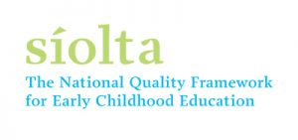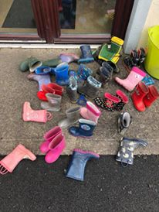

In 2015 we won the “Innovation in Celebrating Community” Award from Early Childhood Ireland in recognition of our learning of the community we live in.
In 2016 we were awarded the accolade of “Healthy Ireland Preschool Service”. This programme focused on health promotion, oral health, nutrition health and safety, physical activity, and emotional well-being, it is run by the HSE.
In 2017 we were successful in achieving our “Síolta Quality Assurance Award”, this is a national award aimed at ensuring high quality childcare settings are recognised. We were successful in retaining our Síolta award in 2022 scoring top marks in all categories.
This year 2023 we have again been awarded the Healthy Ireland Smart Start Award; this award recognises all pre-school services that participated in the HSEs Healthy Ireland Smart Start programme delivered by NCN. The award acknowledges the role and influence the pre-school setting has in promoting children's health and well-being.
Partnership with Parents and Guardians
Ardfinnan Community Playschool gives parents and families opportunities to share, get involved and make suggestions about all the activities happening in our service. Families are the most important people in their children’s lives, and we are committed to be open, inclusive, welcoming, accepting, and respectful of all family types. As a partnership we ask families to show respect and value for all staff, children, and families in return. Our partnership is an opportunity for sharing lots of information which can help parents understand our approach and can also be a chance for parents to actively engage and support the changes we are making.

Open Door
Ardfinnan Community Playschool operates and encourages an open-door policy. This policy encourages parents/guardians to call to the playschool at any time throughout the day, as we believe that co-operation between staff and parents/guardians in all aspects of decision making can benefit their child. If a parent or guardian would like to speak to a member of our staff about their child’s learning, we recommend parents make an appointment so as not to disrupt the daily routine of the children in our playschool or our child: adult ratio. Parents or guardians may arrange a time that suits both them and staff to talk by ringing or texting the playschool office.

Procedures
- All families will be greeted on arrival by a staff member. This is an opportunity to share information and grow the relationship between our service and families
- We will share information with our families in number of ways including daily conversations, letters, emails, phone calls, our newsletter and text messages
- Information on children’s progress, interests and development will be shared daily through conversation and pre-arranged appointment times
- Ardfinnan Community Playschool ensures all families are consulted with during periods of change or decision making
- There are lots of opportunities for formal and informal conversations with both staff and manager
- Involvement on management committees by parents is encouraged
- We ask families to get involved with activities, outings, and fundraising events. It is voluntary and there is no obligation to take part.
- Information on how family’s contribution of their skills and sharing of individual interests are valued and accommodated throughout our playschool year
- We value and appreciate any information on family customs, belief, language, and culture
- As a partnership we ask all families to respect the staff, children, and other families in the setting
- Any complaints, concerns or comments should follow the procedure in our Complaints Policy
- Parents are provided with a handbook giving details of the service before the child starts at the service

Ardfinnan Community Playschool provides time to meet with parents to discuss their:
- Child’s progress and documented learning
- The child’s relationships and interests
- Suggestions for the service.
- Joint behaviour management if necessary
- Difficulties or concerns.
Parent feedback is constantly encouraged by management on an on-going basis.

Procedures for parents before a child start playschool with
Ardfinnan Community Playschool
We ask parents to:
- Ensure their child is fully toilet trained before beginning their playschool journey with us. Ardfinnan Community Playschool regrets that they do not have the facilities to change nappies but has the facility to help children who may have accidents to change their cloths. Please talk to our Room Leader if you have any issues relating to your child’s needs as we may be able to help.
- Please ensure that all parts of your child’s enrolment form are filled out. This information is required by both Ardfinnan Community Playschool and the HSE. It is open to inspection by the HSE Preschool Inspector.
- Please supply a copy of your child’s immunisation record on enrolment.
- Please ensure that you have read this book and you agree to the terms set out when placing your child in Ardfinnan Community Playschool.
- Dress their child in old cloths coming to playschool. Messy play is important for young children, it gives them endless ways to develop and learn, we have great fun throughout our time in playschool, painting, digging in the garden, making play dough, water play and lots more, we recommend that your child wears old clothes coming to playschool each day as “good clothes” cannot be minded.
- Please supply their child with a school bag coming to school each day, this is an important part of each child’s learning each day, taking out their lunch and tidying it up again after lunch, hanging up their bag on their hanger, bringing their artwork home, storing their spare clothes and lots more.
- Please put a full change of clothes in their child’s school bag with their name printed on each item of clothing, we understand accidents can happen from time to time and children may need a change of clothes during their day at playschool, sometimes our play is messy, and your child can get wet from water play, muddy from digging. Children are encouraged to get their school bag and change their clothes, when necessary, with the help of staff. We ask that parents keep in mind the changing seasons when providing a spare change of clothes.
- To keep in mind the changing seasons, when bringing children to playschool, children need a coat and hat each day for the cold weather as we go outside everyday even in cold weather. In hot weather children need sun cream, a sun hat and their shoulders covered. We recommend that parents put on sun cream prior to dropping their child to playschool, their child can bring their sun cream in their school bag and staff will help the child if they need to apply more during the day. Please ensure the sun cream bottle has your child’s name on it and all put your child’s name on their coats and hats.
- Provide their child with a SMALL HEALTHY SNACK and WATER or MILK each day coming to playschool. We recommend a piece of fruit or vegetable, a yogurt and a bottle of water or a small sandwich, some chopped fruit or vegetables and milk, there are lots of ideas for lunch boxes on www.safefood.eu. Each child brings home any uneaten snack as it gives parents knowledge of what their child has/hasn’t eaten during playschool.
- Your child’s drinks bottle will be stored in their school bag and your child will have access to it throughout their day. We ask that you provide your child with only water or milk each day in a small bottle labelled with your child’s name. We can refill their bottles with water at any time.
Please be aware popcorn is not allowed in our service.
We ask parents to please not give their child treats coming to school as we have a healthy eating policy, and all treats will be sent home except on special occasions such as a birthday.
Celebrations
Birthdays are an important milestone for all children and at Ardfinnan Community Playschool we always mark the occasion with a small party. If parents wish to bring in any food items such as a birthday cake or buns, they are welcome to do so but must ensure that food items are wrapped in original store packaging noting expiry dates and all ingredients. Parents must also comply with any allergy restrictions that are in place at that time, e.g., no nuts, eggs, or gluten procedure.
Ardfinnan Community Playschool is also very mindful of different faiths and their recognition and celebration of birthdays, Christmas, Easter and such, the Room Leader will always contact parents prior to celebrating any occasion.

We have a detailed healthy eating curriculum where children learn all about what foods are healthy and how they help our bodies to grow.

Allergies
Due to food allergies, we would like to make parents aware that there may be a possibility of us asking that certain foods such as some fruits, nuts or eggs be left out of lunches. Parents should inform playschool if their child has food intolerance on enrolment.

Inclusion
Ardfinnan Community Playschool has a policy of equality of care, respect, and value for all children. We welcome and support children with additional needs, and their families. These needs may be physical, intellectual, social, and emotional. Language may be a problem due to a specific need in this area, or because English is not the first language of their child. We encourage parents to write a few words that have special meaning to their child so staff can understand their needs.
We aim to provide a physically accessible indoor and outdoor environment and work with parents to support their child’s physical development and/or needs while attending our playschool.
We also work closely with external agencies e.g., HSE, Early intervention teams, speech, and language, etc.
We support each child’s learning by setting up an agreed means to review, examine and assess the programmes for every child ensuring each child’s interests are included in our curriculum and we encourage parents to be involved in their child’s learning.

LINC and AIM program
LINC (Leadership for Inclusion in an Early Years Setting) this is a national programme designed to enhance inclusion of children with additional needs in early childhood care and education settings Erica Condon is our Inclusion officer (INCO) she has completed her LINC training which is a Level 7 Special Purpose Award in Leadership is for Inclusion in an Early Years setting. Erica’s role is to ensure best practice is being implemented in leading the inclusion of children with additional needs in our playschool. Erica will support all our Educators to plan for, implement and review inclusive practice in our playschool.
Erica will also engage with the children ensuring their needs, ideas, feelings, and thoughts are listened to. Erica advocates on their behalf to ensure Inclusion procedures are in place. She will liaise with parents and other professionals working with their child e.g., speech therapist, through the AIM (Access and Inclusion Module) program.
All our staff have gained a certificate in the implementation of AIM (Access and Inclusion Module) and have valuable experience working with children who have special needs.
Please contact Erica for more details.

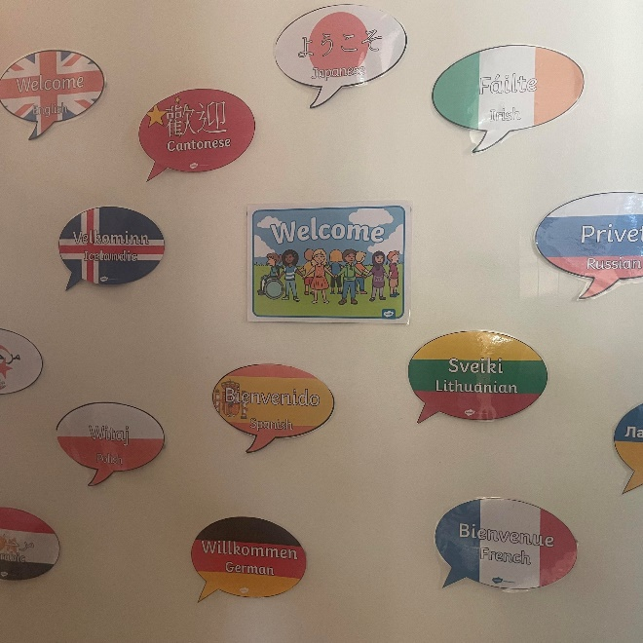

Child Arrival and Collection
Policy Statement
Ardfinnan Community Playschool promotes arrival and departure time as an opportunity to actively engage with children and families to help with the children’s transitions. We understand that arrival and collection are our busiest times throughout the day and are committed to following strict guidelines to ensure all children’s safety is protected. This policy outlines the protocols in relation to arrival and collection of children from Ardfinnan Community Playschool.

Purpose of this Policy is to….
- To ensure the welfare and safety of the children in the service.
- To ensure that children are received into the service safely and securely, and that parents/guardians/carers make direct contact with the appropriate staff members on arrival each day with their child.
- Parents/guardians/carers are encouraged to stay until their child is safely in the playroom before leaving the building
- To encourage all parents/guardians or carers to come for their children on time.
- To ensure children are returned safely into the care of their parents/guardians or carers.
- In cases where a parent/guardian/carer does not arrive on time for their child at the end of their session, to ensure that the child is cared for safely by at least one competent staff member who is known to the child.
- To support staff members in handling challenging or exceptional circumstances related to the children leaving the setting daily.

Parking: There are 5 parking spaces and 1 disabled parking space in our playschool, there is also ample roadside parking. We ask all parents/guardians, family members, carers, and visitors to exercise particular care when parking in the playschool or the road beside us as our pre-schoolers and their young siblings may not be visible to drivers.
A speed limit of 5KM per hour is in operation within our premises.

Procedures for dropping your Child:
- On arrival parents/guardians/carers must ensure that they make direct contact with a member of staff and pass on any information that is relevant to the child’s care for the session.
- A staff member will meet you at the gate to receive your child and bring them into our playroom, the staff member will also sign in your child in the sign in/out book. While we encourage conversations about your child these will have to be kept to a minimum, staff are available to talk on the phone or you can arrange an appointment at any stage to discuss your child’s learning and care.
- Both staff and parents/guardians should make every effort to support the child’s transitions each day through daily conversations and moral support
- Staff will assist your child with their coats and bags upon entering
- We recommend that all lunches and drinks remain in your child’s school bag for the duration of playschool, they will of course have free access to their school bags throughout the day.
- We ask that parents/guardians/carers not open our garden gate, or lift children over the fence.
We hope we can make the arrivals a positive experience for all as we understand that separation is hard not only on the child but also on the parent or guardian.
Procedure for Collecting your Child
As with arriving we ask all to be mindful of small children when driving into our playschool. On arrival to collect your child please wait near the garden gate, a staff member will let your child out the gate to you. The staff member will sign out your child in our sign in/out book
Staff will tell you how your child spent their day, giving you a brief description of our activities; if you need more information or would like to talk to a member of staff, please make an appointment or we can arrange a phone call with you.

- If a child is to be collected by a person other than their parent a prior signed parental permission must be in place, see enrolment form
- The parent should provide the name, address, contact number of the persons authorised to collect their children and state the relationship of this person to the child
- All authorised persons must be over 18 years of age.
- Children can only be collected by an authorised person.
- Photographic I.D is needed for authorised persons not known to staff; this includes parents.
- On collection, parents/ guardians are encouraged to meet with staff so they can share information about the child’s day.
- Ardfinnan Community Playschool should be informed if one parent does not have guardianship and access to their child.
- Ardfinnan Community Playschool should be informed immediately of any changes to those authorised to collect their child.
- Under NO circumstances will a child be released to the care of a person unknown to staff or unauthorised by a parent/guardian
- Parents are asked to notify Ardfinnan Community Playschool of any changed to their nominated persons
- Educators can seek emergency medical assistance for a child as required without seeking further authorisation from a parent or guardian (i.e., medical practitioner, ambulance, or hospital) including for those emergencies relating to asthma and anaphylaxis.

We ask all parents & visitors to our playschool NOT to open the garden gate, this is to ensure the safety of all children in our playschool,
Settling In
We recognise that as parents you play the LEADING role in helping to prepare your child for preschool. It is with this in mind we developed our settling in policy.

We would like the settling period for your child to be a positive experience and we will work together with you as a parent to ensure that it is. We recognise that children develop in individual ways and at varying rates and that is why at Ardfinnan Community Playschool we offer a settling in procedure that is flexible to meet those needs.

First Few Days, helping your child to transition from home to playschool
Parents are encouraged to leave their child as quickly as possible as the children usually find it distressing if too many unexpected strangers (and other children’s parents are unexpected strangers to a small child) hang around.

Children need to feel safe, stimulated, and happy to develop and grow socially, emotionally, and physically. They need to feel secure and comfortable with the Educators at Ardfinnan Community Playschool. We also want parents to have confidence in both their children’s wellbeing and play an active part in their child’s settling in.
There are a number of strategies to help your child settle in our playschool these can be discussed with staff to ensure best care for your child and their time with us. These may include:

- Visiting the playschool prior to your child starting school, explaining to him/her what their day at playschool will include focusing on fun and friendship
Ardfinnan Community Playschool holds open days prior to starting a new year; all children enrolled to start are invited to attend with their parents. The children get to experience our playschool, investigating the playroom and garden, discovering what toys are there to play with, see and meet some other children who will be in their class. Parents also get the opportunity to meet all staff members, and other parents.

- Gradually building up the time your child attends playschool
If your child is finding it hard to settle, please speak to a staff member, we are very flexible and have a number of strategies in place to help you and your child, these may include varying the times your child attends playschool, such as coming before or after everyone else, bringing a favourite teddy or comfort blanket to playschool. Please speak to a member of staff they are always willing to help.

- Using the educator’s names when speaking about playschool to your child so as they are familiar with staff when they arrive at playschool,
Knowing and being familiar with who is looking after your child, speaking their names, and talking positively to your child about playschool will ease their fears of starting or going to playschool

- Encourage your child’s confidence and independence by praising them when dropping and collecting them
Saying goodbye is very important to your child, they may need reassurance that you are coming back for them, children also need to know who is collecting them and why.

Supporting Parents
We understand that parents can find it very stressful when they are leaving their child to be cared for by someone else
Ardfinnan Community Playschool will support parents who may need reassurance by:
- Listening to parents’ concerns, acknowledging them, and taking them seriously.
- Reassure parents through video calls, text messages and sharing a picture of their child playing after they have left (to ensure Data Protection we ask parents NOT to share these pictures).
- Keep in contact with parents to let them know how their child is doing and reassure them that they are being well cared for.
- Supporting children, who may feel distressed, sometimes distress might be obvious, and they may protest loudly, cry or try to leave the room. For other children, their distress might not be so obvious. Some children might be quiet or withdrawn or appear to be busy with toys while being overwhelmed with feelings. All our staff are fully qualified to recognise when a child is distressed and have a number of strategies to help the child feel comfortable in their surroundings, if you are worried, please talk to a member of staff.

Confidentiality
Ardfinnan Community Playschool is committed to keeping all information about the children, families, staff, and volunteers using the service confidential. Unless there is a child protection obligation for to disclose such information or the service is legally obliged to do so.
- Parents have the right to access the files and records of their children but will not have access to information about any other child.
- Staff will not discuss individual children, other than for the purposes of curriculum planning/group management, with people other than the parents/carers of that child
- Accidents resulting in injury will be shared with the authorised person who collects a child. Information of a sensitive nature will only be shared with parents of that child and any person that the parent has nominated to share information with as noted on the child’s registration form
- Feedback is given directly to parents on their child’s progress
- Information about a child’s medical needs or status, or concerns about child protection issues will be kept in a locked file and will only be available to authorised personnel.
- Information is shared on a need-to-know basis only
- All confidential information will be stored securely,

Ardfinnan Community Playschool is fully compliant with GDPR Data Protection 2016.

Fees
Policy Statement
Ardfinnan Community Playschool fees reflect both the need to offer high standards of practice and affordability to parents. We are committed to working together with parents to ensure quality care and learning for their child
Principle:
This policy is underpinned by the National Standards for Preschool Services 2010, the Child Care Act 1991 (Early Years Services) Regulations 2016 and the Equal Status Acts 2000-2012.

The committee are responsible for establishing fees policies and structures which must be approved by the Board of Management at Ardfinnan Community Playschool and the Tipperary County Childcare on an annual basis.
All money generated from fundraising for the service must be lodged into the bank account of Ardfinnan Childcare Committee Company Limited by Guarantee.
Fees are to be paid in the reception office at Ardfinnan Community Playschool. Management will ensure regular lodgements or contact the Treasurer if time constraints prevent lodgements.

FEES PAYMENTS
The rate is €14 per session.
Fees should be paid weekly on Monday or the first date of attendance each week.
Receipts are issued on request only.
There will be no reduction in fees if a child is absent due to illness, or any such reason.

PAYMENT OPTIONS
Weekly in advance: fees should be paid on Monday or the first date of attendance each week.
Monthly in advance: There is an option to pay fees on a monthly bases, please speak to Administrator for details
Quarterly in advance: There is an option to pay fees on a term-by-term bases, please speak to Administrator for details

LATE PAYMENT
If one month’s fees are outstanding at the end of the 2nd month a written reminder will be issued.
If fees are still outstanding and no contact has been made after the 3rd month the service is withdrawn.

Record Keeping
Ardfinnan Community Playschool will keep records regarding all children and staff as stated in The Child Care Act 1991 (Early years Services) Regulations 2016.
Records are kept to ensure the safety and wellbeing of all children and adults. Attendance records are kept on a daily basis for both children and staff. We also keep records of our fire drills and a daily record of our curriculum. These records help enhance the overall running of our playschool.

A pre-enrolment form must be completed by each child’s parent/guardian when booking a place in our playschool. Prior to each child starting playschool parents/guardians are invited to attend our opening day where they will have the opportunity to meet with other parents and staff. Management will contact parents with their child’s Registration Form which has to be returned before your child starts playschool, this and all information is kept securely locked in a filing cabinet.
Health information and accident reports are also kept. Immunisation records will be needed before a child starts playschool.

All records including personal details, contact records, observations and assessments of the children are kept in the strictest of confidence. A parent/guardian can access records relating to their own child only. All our records must be open to inspection by Tusla.

Social Media
Ardfinnan Community Playschool has a detailed policy on Media and Communications which covers all areas of Media and Communications; this is available to view in our office.
Our Enrolment form contains a section on Consent for use of Photos and Videos and how these will/may be used. These Consent forms must be signed by parents/guardians and copies of the enrolment forms will be provided for the parents when requested.
Parents/guardians have a right to refuse or to withdraw permission at any time.
Images cannot be used for purposes other than those agreed.
All images are to be stored and disposed of in line with the Data Protection GDPR 2016.
Where group photos of children are taken, they will not be shared unless consent is given by ALL parents/guardians.
Facebook: Ardfinnan Community Playschool has an active Facebook page which it updates on a regular basis with notices of our activities, holiday dates, general information and pictures of some arts and crafts the children have done.
On occasions we also post group pictures of the children e.g., Christmas Concert, Graduation.
Facebook is an excellent opportunity for our playschool to connect with parents and share special photos instantly on its private message system while also posting pictures of our celebrations during the year.
Parents are given the option of allowing their child’s picture to be posted by signing a consent form when enrolling their child.
We ask that parents refrain from sharing private pictures of their child in playschool that are messaged to them

Our Curriculum
Ardfinnan Community Playschool recognises that children are often filled with curiosity about the world around them and through our curriculum we have the opportunity to support and develop a lifelong love of learning for each child. Our emerging play-based curriculum supports planned learning, spur-of-the-moment learning, adult and child led learning.
Ardfinnan Community Playschool’s emerging curriculum planning is based on the following principles:
- Quality care is educational and quality education is caring.
- Play is central to the well-being, development and learning of the young child.
- Learning is holistic and cannot be compartmentalised: trust, motivation, interest, enjoyment, and physical and social skills are as important as cognitive/academic gains.
- The child’s needs, rights, individuality, and strengths are central.
All children are entitled to equality of access and opportunities to enjoy and learn within a stimulating and safe care environment. We encourage children to become independent learners and to discover learning is fun through structured and spontaneous activities. Planning an emerging curriculum requires observing, listening, and talking to the children in order to capture their interests. These interests are explored through play indoor and outdoor, group discussion, books, experiments, arts and crafts, music dance, group projects, jigsaws, play dough, and other learning tools.
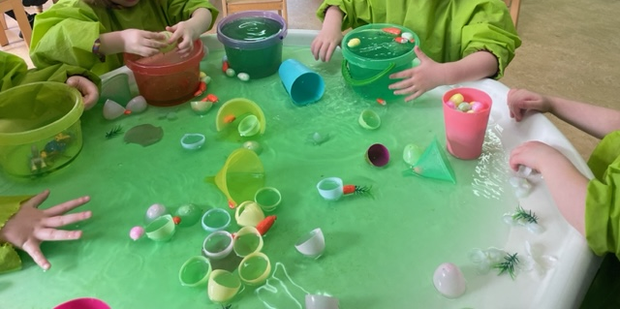
Free Play within our Curriculum
Research tells us that children use free play to express their emotions and learn to deal with their fears and scary experiences. When playing freely, children can process emotions and ‘play out’ their fears and traumas. This happens in a very natural way and is healthy and should be encouraged. Our role as educators is to provide the environment, the opportunities and especially the time for this to happen.
The essence of free play is that it is child-led, child-initiated, and not directed by adults. Outdoor play in a natural environment is best for this type of play; our garden is a beautiful area where magic happens, throughout the day the children will have the choice to play outside or in the playroom. There is increasing evidence that spending time in natural environments can help children who are exposed to stressful events to be less anxious.

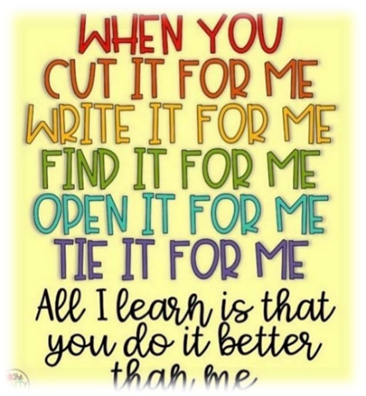

We provide children with the opportunity to:
- Play – Toys and play equipment that are safe are stored within easy reach of children. The environment, space and layout facilitate different types of play and activity:
              - Messy play (water, sand, clay, paint, etc.)
              - Pretend play (clothes for dressing up, variety of materials for role-play and imitation)
              - Construction play (blocks of different textures, Lego, straws, etc.)
              - Social play involving interaction with other children
              - Activities using fine finger movements (jigsaws, threading, drawing)
              - Activities involving music and drama
              - Activities involving whole body movement (ball games, running, dance, etc.)
              - Reading
              - Outdoor play
- Develop academic skills (maths games, time for reading individually and in groups)
- Enhance creativity and express themselves through art.
- Explore and develop interests and talents.
- Learn to work as part of a team.
- Experience the satisfaction of completing both long and short-term hands-on meaningful projects with tangible results.
- Think about and develop positive character traits (such as honesty, kindness, and friendship) and social-emotional competence through projects, discussions, stories, and games.
- Develop leadership skills
- Relax and interact socially with each other.
- Learn about healthy eating

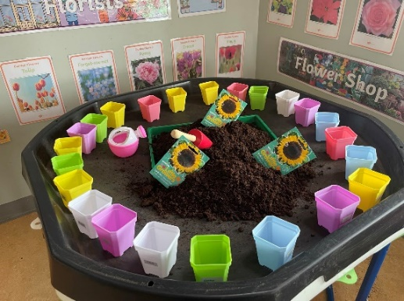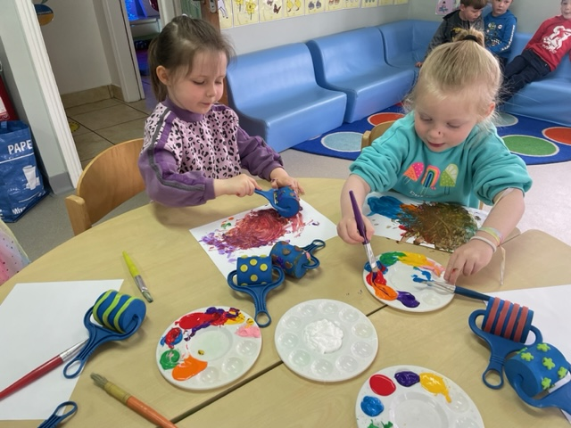
Play opportunities outdoors
The outdoor play area offers children the opportunity to investigate and explore, problem solve, use their imagination and creativity. Children have free choice to play outside or inside at all times throughout the playschool year.
- Children experience social interactions – being able to choose whether and when to play alone or with others, to negotiate, co-operate, compete, and resolve conflicts.
- Long, uninterrupted periods of time are provided for spontaneous free play.
- Open space is available for running, cycling and general free movement.
- Children are encouraged to manipulate the environment and the materials in their own way, to support their play.
- Activities which test the limits of capabilities such as lifting, balancing, and climbing and chase games are included.
- All children, including those with physical impairments/disabilities, have access to play opportunities and are included in play – for children with limited motor abilities and/or health impairments this means that activities may need to be positioned to allow children to relax, to focus attention on the activity and have sufficient controlled movement for independent play.
- The value of messy play, rough-and-tumble play, and nonsense play is recognised.
- Children can enjoy energetic activity and have opportunities to run, jump, scoot, crawl, climb, and ride on wheeled toys.
- The outdoors offers the children opportunities for manipulative play and to develop their fine motor skills.
- Children are helped to care for the outdoor environment through the context of their outdoor play area.
- Children are given opportunities to care for living things (gardening with non-toxic plants)
- Children learn how to use tools safely and effectively and to follow safety rules.
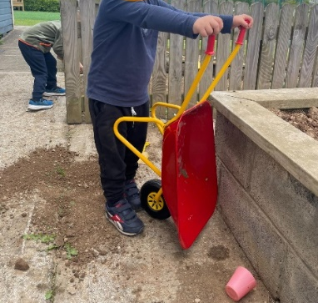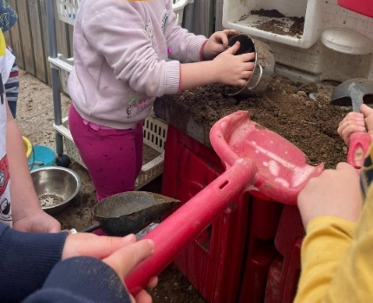
**As always, we have a strict cleaning routine where all toys are washed after each use

Observations
Skilled and careful observation is the key to helping children to learn. Observations are carried out with proper respect for the children, for their parents/carers and for the staff. We respect children’s and families’ ethnicity, their cultural heritage, their religions, and the languages they speak. We respect all children whatever their gifts, abilities, or special learning needs. When we observe children, we attend to the whole of their development not just to certain aspects. Children’s learning to respect one another is as important as their learning to count. Staff members meet children’s needs through sensitive and appropriate interactions that promote their self-esteem.
We observe to:
Understand a child’s developmental progress, strengths, abilities, and interests.
- their hand/eye coordination
- their social skills
- their conversational ability
- Colour recognition
- And much more
Observation allows us to:
- Evaluate our own work
- Evaluate the daily routine
- Plan for change
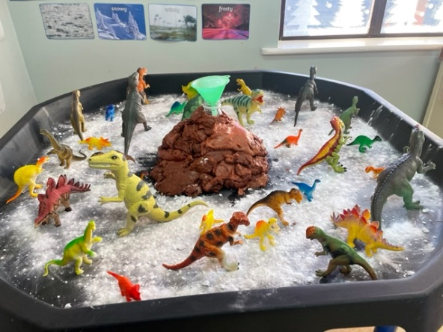

Daily Routine
Our day at preschool consists of
- Free play begins as a child enters the playroom, this consists of interest tables, children have free choice on what they would like to play, make, take out etc.
- Clean up time depends on what the children want to do, if some would like lunch, they may tidy their toys and wash up for lunch or the group as a whole will tidy up together
- Circle time is where we meet to chat, tell each other our news, discuss what we would like to learn next and lots more
- Story time happens throughout the day, staff will read to children individually or as a group, children are also encouraged to read to themselves and to others
- Song movement time, we have a range of musical instruments and some great dance songs which get us all up and moving and singing along
- Outdoor time at all times the door is open and the children have the choice to go out to play or stay in the playroom
- Lunch time is when the child is hungry, sometimes children are too busy to eat or are hungry coming to playschool, staff are sensitive to their needs and recognise when each child needs to eat. We also encourage children to eat together developing their social skills

Healthy Eating
Statement: At Ardfinnan Community Playschool we believe that eating a balanced diet is vital for good health and wellbeing. Food provides the energy, protein, essential fats, vitamins, and minerals to live, grow and function properly. We understand that children need a wide variety of different foods to provide the right amounts of nutrients for good health and development. The food a child eats in their early years influences their eating habits as they grow and develop. We recognise that it is important to teach young children about healthy food choices and staying well hydrated, and to help them develop good habits and a healthy relationship with food from an early age.

Curriculum: Ardfinnan Community Playschool recognise the importance of food in our daily routine, healthy food is a key part of our curriculum, where the children are offered learning on the food pyramid and how to choose a healthy choice for a snack, fruit and vegetables are available to explore and taste during this learning. Our garden is also a key learning experience for the children where we may grow vegetables or herbs or fruit.

we experiment to see how much sugar is in our food, we look at what food animals give us and lots more.
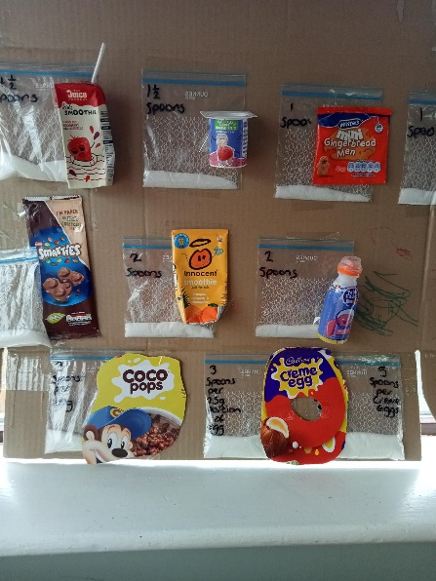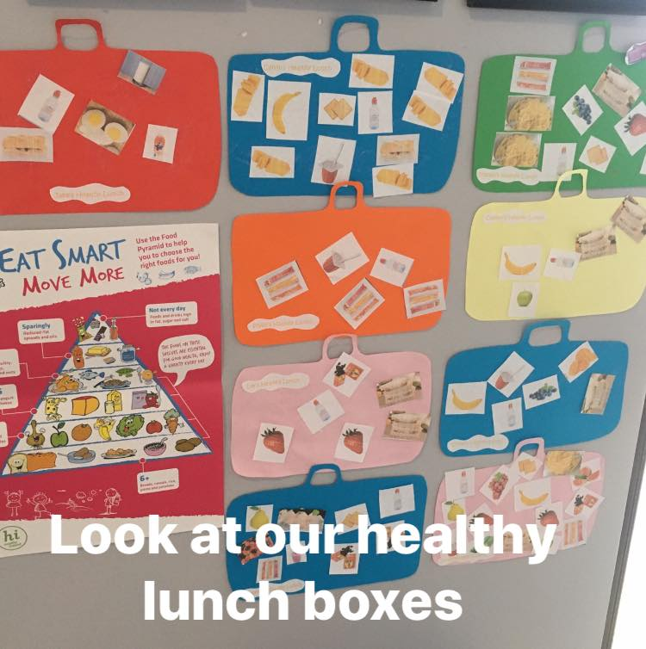
Recommendations for your child’s lunch
Drinks:
- Water is the best thirst quencher.
- Milk is an important part of a growing child’s diet.
- Milk and water are the most tooth-friendly drinks
Snacks:
- Fresh fruit pieces (apple, banana, kiwi orange, plum, pear, pineapple, strawberries, blueberries, tomato) we recommend that all grapes are cut in quarters to reduce the risk of choking.
- Fresh vegetable pieces (cucumber, carrot, celery, salad leaves)
- Cheese slices/cubes and crackers, cheese strings
- Fingers of toast, sandwiches, wraps, pitta bread, scone
- Sliced rolls of cooked ham, tuna, chicken.
- Raisins or other dried fruit
- plain yoghurt
- pasta
- hard-boiled egg
- nuts (pine nuts, peanuts)

Ardfinnan Community Playschool has adopted a healthy eating and nutrition policy recognising that healthy eating is a key part of learning in preschool; it is a valuable life skill as we believe that learning about how to eat healthy, drink healthy, getting exercise at a young age and being able to take responsibility for making good health choices and caring for themselves enables children to experience wellbeing and lays the foundation for a healthy lifestyle in the future. This is accomplished with the help of parents and guardians, staff and management.

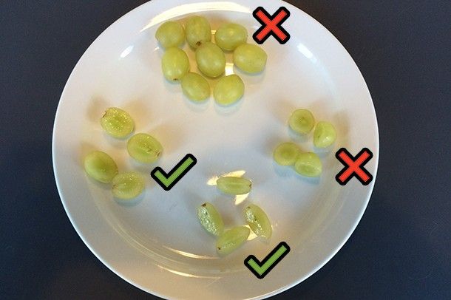
Safety First: please be mindful of your child’s safety while eating and cut fruit or vegetables to an appropriate size for them. When cutting Grapes please follow the following guidelines to ensure your child’s safety when eating them.
- Grapes should always be cut lengthwise so they can pass more easily through smaller throats, and never width wise, because they’ll still be big enough to choke on.
- for children experiencing difficulties with swallow or smaller children, you might want to cut them lengthwise then cut them again into quarters

Hand Hygiene
Ardfinnan Community Playschool aims to keep children happy and healthy by supporting the children to understand the importance of hand washing. We are supported in our curriculum by Safefood.ie. Rufus our hand washing hero helps us understand the benefits of washing our hands. The aim of this programme is to make learning good hand washing habits fun and help to protect children from nasty bacteria’s which can make children ill.
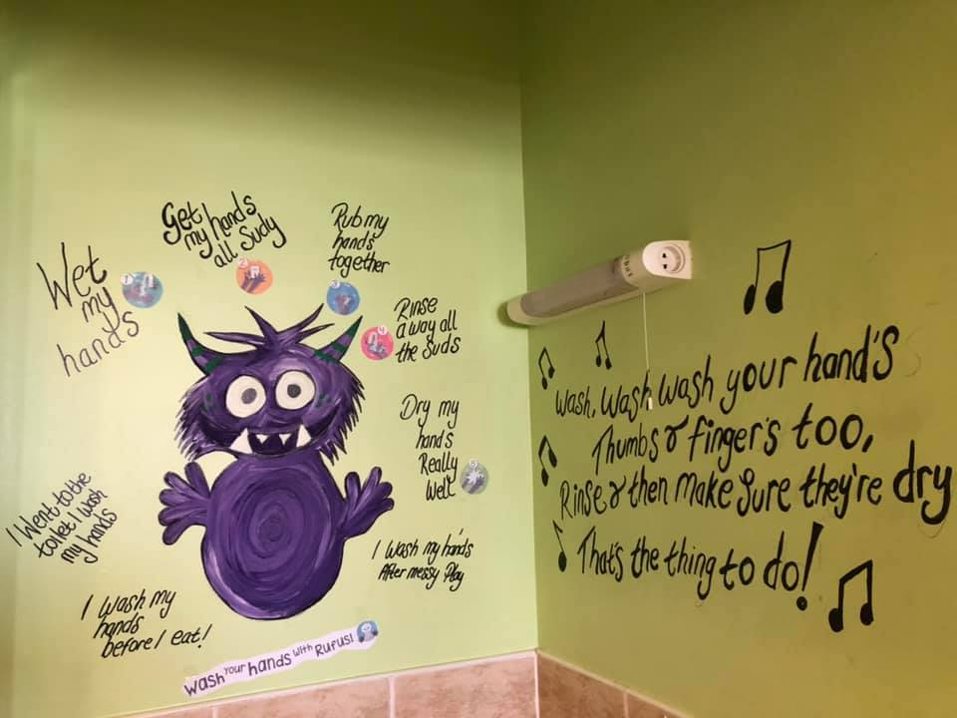
Check our Safe food website for more details on Rufus the hand washing hero
Procedure for Hand Washing
- Hand washing facilities are available the playroom toilets
- Children can avail of the hand washing facilities when they need it, and they will be encouraged and supported to practice this new skill.
- Wash hand basins have hot and cold taps, hot taps are thermostatically controlled to ensure that hot water is a suitable temperature for children so as to avoid scalding and facilitate hygienic hand washing.
- Staff encourages children to wash their hands upon entering each morning, after using the toilet, before eating any food, messy play and after playing outside.
- Guidelines on hand washing are displayed in the playroom and toilets. These guidelines incorporate visual images that are appropriate for staff and children.
Procedure for Respiratory Hygiene
- Staff encourages children to cover their mouth and nose with a clean tissue when they cough and sneeze and then promptly dispose of the tissue in a bin and wash their hands. If they don’t have a tissue, staff will encourage them to cough or sneeze into the bend of their elbow instead, not into their hands. Tissues will be freely available throughout the playschool.

Aistear
Ardfinnan Community Playschool implements the Aistear Framework in line with the guidelines set down by the National Curriculum Framework. Aistear is the Irish work for journey, and it provides information for adults to help them plan for and provide enjoyable and challenging learning experiences, so that all children can grow and develop as competent and confident learners within loving relationships with others. It also lays foundations for later learning, as early childhood marks the beginning of children’s lifelong learning journeys.
The aim of Aistear is to help every child to grow and develop as a competent and confident learner. Ultimately, according to Aistear, early childhood care and education must support a child’s sense of:
- Well-being: by developing meaningful relationships with children and allowing them to express their feelings
- Identity and Belonging: by promoting each child’s uniqueness, by sharing control with the children, by providing an environment where they can find things for themselves
- Communicating: by asking children what they plan to do and reviewing what they have done and by talking about problems to resolve them together
- Exploring and Thinking: by providing a wide range of materials that children can choose to use in whatever way they desire by embracing nature at outside time by providing opportunities for mathematics and science language and literacy music and movement
These are the 4 main goals of Aistear, and it proposes that they are achieved through the contexts of play and supported by caring, learning relationships with adults and peers and firmly establishes the child’s right to a safe, stimulating, nurturing and play-based environment.

Síolta
Síolta is the National Quality Framework for Early Childhood Education. Its core elements comprise of three distinct but interrelated elements: Principles, Standards and Components of Quality. The 12 Principles provide the overall vision of the Framework, while the 16 Standards and 75 Components allow for the practical application of this vision across all aspects of our practice. The Components of Quality are further set out through a set of Signposts for Reflection and ‘Think-abouts’ which support us in our daily practice.
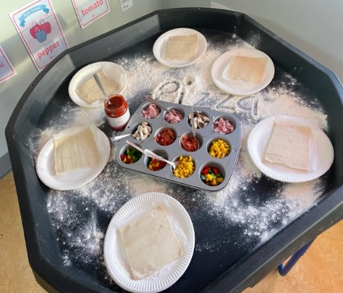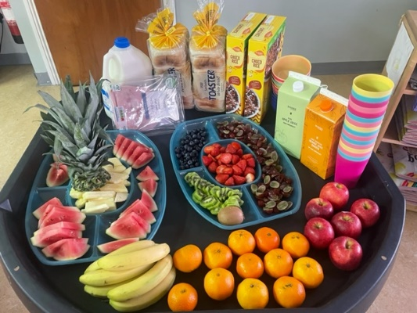
There are 16 Standards which are:
Standard 1: Rights of the child
Ensuring that each child's rights are met requires that she/he is enabled to exercise choice and to use initiative as an active participant and partner in her/his own development and learning.
Standard 2: Environments
Enriching environments, both indoor and outdoor (including materials and equipment) are well maintained, safe, available, accessible, adaptable, developmentally appropriate, and offer a variety of challenging and stimulating experiences.
Standard 3: Parents and Families
Valuing and involving parents and families requires a proactive partnership approach evidenced by a range of clearly stated, accessible and implemented processes, policies, and procedures.
Standard 4: Consultation
Ensuring inclusive decision-making requires consultation that promotes participation and seeks out, listens to and acts upon the views and opinions of children, parents and staff, and other stakeholders, as appropriate.
Standard 5: Interactions
Fostering constructive interactions (child/child, child/adult, and adult/adult) requires explicit policies, procedures and practice that emphasise the value of process and are based on mutual respect, equal partnership, and sensitivity.
Standard 6: Play
Promoting play requires that each child has ample time to engage in freely available and accessible, developmentally appropriate, and well-resourced opportunities for exploration, creativity and 'meaning making' in the company of other children, with participating and supportive adults and alone, where appropriate.
Standard 7: Curriculum
Encouraging each child's holistic development and learning requires the implementation of a verifiable, broad-based, documented, and flexible curriculum or programme.
Standard 8: Planning and Evaluation
Enriching and informing all aspects of practice within the setting requires cycles of observation, planning, action, and evaluation, undertaken on a regular basis.
Standard 9: Health and Welfare
Promoting the health and welfare of the child requires protection from harm, provision of nutritious food, appropriate opportunities for rest, and secure relationships characterised by trust and respect.
Standard 10: Organisation
Organising and managing resources effectively requires an agreed written philosophy, supported by clearly communicated policies and procedures to guide and determine practice.
Standard 11: Professional Practice
Practising in a professional manner requires that individuals have skills, knowledge, values and attitudes appropriate to their role and responsibility within the setting. In addition, it requires regular reflection upon practice and engagement in supported, ongoing professional development.
Standard 12: Communication
Communicating effectively in the best interests of the child requires policies, procedures and actions that promote the proactive sharing of knowledge and information among appropriate stakeholders, with respect and confidentiality.
Standard 13: Transitions
Ensuring continuity of experiences for children requires policies, procedures and practice that promote sensitive management of transitions, consistency in key relationships, liaison within and between settings, the keeping and transfer of relevant information (with parental consent), and the close involvement of parents and, where appropriate, relevant professionals.
Standard 14: Identity and Belonging
Promoting positive identities and a strong sense of belonging requires clearly defined policies, procedures and practice that empower every child and adult to develop a confident self- and group identity, and to have a positive understanding and regard for the identity and rights of others.
Standard 15: Legislation and Regulation
Being compliant requires that all relevant regulations and legislative requirements are met or exceeded.
Standard 16: Community Involvement
Promoting community involvement requires the establishment of networks and connections evidenced by policies, procedures and actions which extend and support all adult's and children's engagement with the wider community.
Ardfinnan Community Playschool received its first Síolta Award in 2017 and again in 2022, and continues to engage in the process of providing a quality preschool service.
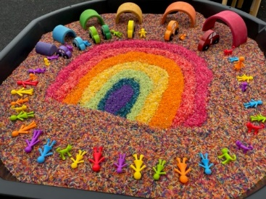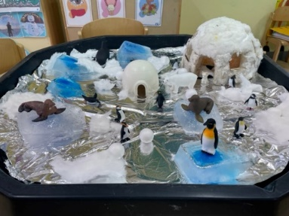
Cleaning
We at Ardfinnan Community Playschool implement good practice and work effectively to ensure our service is maintained to a very high standard. All employees are required to follow the cleanliness and hygiene procedures.
Ardfinnan Community Playschool will be maintained in a clean, hygienic state throughout the day and cleaning records are kept. Our staff are responsible for the materials and equipment used. They ensure that such items are clean, hygienic, and safe at all times.
The following measures are taken to encourage a clean hygienic playschool, ensuring that all measures taken follow the guidance of the HSE to prevent the spread of infection:
- Cleaning routines and procedures are in place and are closely monitored and recorded.
- All surface areas will be cleaned and disinfected after use and prior to a new session beginning
- Bins are provided for the disposal of tissues and staff will make sure they do not overflow.
- Hand sanitizers will be checked regularly to ensure they are full
- Increase the frequency and extent of cleaning regimes and will ensure that they include:
- Clean regularly touched objects and surfaces using a child safe cleaning product
- Pay particular attention to high-contact areas such as door handles, coat rails, plastic-coated or laminated worktops,
- Desks, access touchpads, telephones/keyboards in offices, and toilets/taps/sanitary fittings.
- Wear rubber gloves when cleaning surfaces, wash the gloves while still wearing them, then wash your hands after you take them off.
- Selection and management of toys from an infection prevention viewpoint; In line with existing national guidance, we will
- Choose toys that are easy to clean and disinfect (when necessary) and dry.
- In the context of the pandemic, the use of certain types of toys (e.g., soft toys, stuffed toys, play dough) will be considered carefully. If their use is considered important for the children, we will avoid sharing these items between children in so far as is practical. Play dough will be replaced daily and soft toys will be washed regularly.
- Encourage children not to bring toys/comfort blankets to playschool. If soft toys/comfort blankets are essential for some children, we ask that parents clearly label them with their child’s name and once home they must be machine washed before being brought back to the playschool. Children are asked not to share such toys with other children and where possible keep them in their school bag.
- Jigsaws, puzzles, and toys that children are inclined to put in their mouths must be capable of being washed and disinfected.
- Discourage children from putting shared toys into their mouths.
- Store clean toys and equipment in a clean container or clean cupboard.
- Always follow the manufacturer’s cleaning instructions.
- Always wash your hands after handling contaminated toys and equipment.
There are morning and afternoon groups in the same room, after each session a deep clean will be completed, there are separate boxes of toys for each group and toys will be cleaned after every use

Steps to eliminate the risk of infection
To help eliminate the risk of infection spreading Ardfinnan Community Playschool will
- Do whatever is practical to make sure that people with symptoms of COVID-19 do not enter the playschool at any time.
- Take all practical precautions to reduce the chance of spread of virus all the time just in case an infectious person with no symptoms is in the playschool. This includes greater attention to hand hygiene, respiratory hygiene, and cleaning. It also means limiting contact between people, keeping groups as small as possible and limiting mixing of people between the different groups. If someone who is not sick is shedding the virus, but they only mix with one fairly small group the number of people exposed to risk of infection is smaller.

If your child does not feel well:
If your child has symptoms of viral respiratory diseases, even if they are mild, they must not attend a childcare setting. If your child becomes ill while attending our playschool, you must collect them as quickly as possible.
If your child has a stomach bug, they must remain at home for 48 hours after last episode of vomiting.
We ask parents not to administer medicines like “Calpol” etc. to their child prior to attending playschool, if your child needs such medicines, we ask that you keep your child at home, unless it is given under doctors’ orders and the doctor gives permission for your child to attend. If your child has a temperature higher than the normal rate of temperature 37 degrees Celsius, they must stay at home. “In children, any temperature of 38 degrees Celsius or above is considered high”, https://www2.hse.ie/conditions/high-temperature.html
Is it safe for children to return to playschool?
Ardfinnan Community Playschool have implemented a number of measures to limit the risk of infection including measures to prevent the spread of infection. Staff will focus on ensuring appropriate infection prevention and control by following advice from the Health Prevention Surveillance Centre (HPSC). In this regard, we ask parents to also follow their advice. Ardfinnan Community Playschool will focus on the following in particular:
- handwashing and ensuring that children learn good hand-washing techniques
- respiratory hygiene and ensuring that children learn good techniques
- ensuring good cleaning procedures in settings
- washing toys regularly
- spending more time outside with the children
Our staff will continue to safeguard children’s needs for physical care and ensure that they all feel safe, nurtured, and supported, that they have a sense of belonging and enjoy their experience.

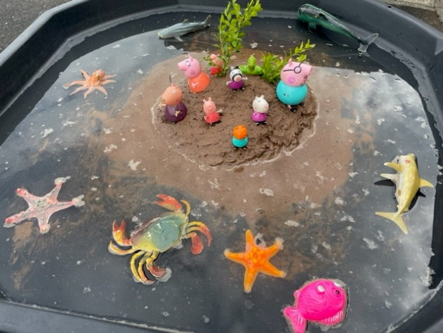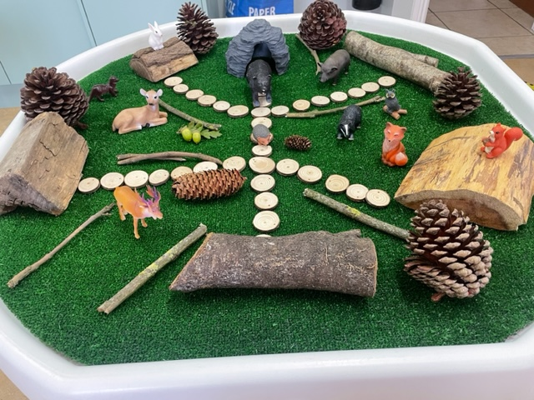

Terms and Conditions
- Children must be 2 years and 6 months prior to starting playschool
- Children must be fully toilet trained
- Parent/guardian must complete and enrolment form and any necessary consent forms in full prior to commencement of playschool
- Parent/guardian must accept or decline their child’s involvement in our Facebook page by signing on the enrolment form
- Children must be fully vaccinated, and your child’s immunisation history must be presented on or before the first day of attendance
- Fees (where applicable) must be paid on the first day your child attends each week (please put moneys in an envelope marked with your child’s name on the front of it)
- Failure to pay fees will result in your child’s place being cancelled/lost
- An adult must accompany your child to playschool and make contact with staff on arrival
- Only adults authorised by you the parent/guardian may collect your child from playschool
- Children must be collected on time: morning sessions are 9:00 to 12:00 and afternoon sessions are 1:00 to 4:00
- Please be aware that there is a fee for late collection
- The playschool staff must have contact numbers for you and any other authorised adults regarding your child in case of an emergency
- Children should bring a light healthy snack to playschool each day
- Bringing toys to playschool is discouraged as guaranteeing their safe return is not possible
- Sensible clothing is essential for playschool, jewellery should not be worn
- Please inform playschool staff of any changes in your household which may affect your child in playschool
- Please inform staff if your child is ill and the illness is contagious
- Please inform staff if your child will be absent from playschool
Policies and Procedures
ARDFINNAN COMMUNITY PLAYSCHOOL quality of practice is underpinned by a set of policies, procedures and practice guidelines which reflect our ethos of providing an open welcoming child centred service, where children will grow and learn in a safe environment. We are fully compliant with GDPR guidelines. All policies are available to view in the reception area. All policies are emailed to parents upon request. Please provide your email to our Administrator and they will email you our policies and procedures.

